**GAME CONCEPT DOCUMENT**

**Medellín CITY**

**Juan David Barrera Urrego**

**Ficha: 1319447**

**Víctor Hugo Cardona**

**Alejandro**

**(Instructores)**

**SERVICIO NACIONAL DE APRENDIZAJE**

**Centro de servicio y gestión empresarial**

**Industrias Creativas**

**Medellín**

**2018**

Contenido

SECCIÓN 1 – RESUMEN DEL VIDEOJUEGO. 2

HIGH CONCEPT. 2

CHARACTERISTICS: 2

MAIN FEATURES: 2

GENDER: 2

TARGET AUDIENCES. 2

VISUAL STYLE 3

SCOPE OF THE PROJECT. 4

SECTION 2 - HISTORY, ENVIRONMENT AND CHARACTERS: 5

THE MAYOR: 5

HISTORY AND NARRATIVE 5

NARRATIVE DESIGN 5

SECTION 3 - GAMEPLAY AND VIDEOGAME MECHANICS 5

OBJECTIVES 5

MECHANICAL 6

PHYSICAL 6

MOVEMENTS 6

OBJECTS 6

SECTION 4 - LEVELS 6

ENVIRONMENT 6

SECTION 5 – INTERFACES 6

GRAPHICAL USER INTERFACES 7

INPUT DEVICES 7

MUSIC 7

MENU MUSIC: 7

GAME MUSIC: 7

SECTION 6 - TECHNICAL ASPECTS 8

HARDWARE AND DEVELOPMENT SOFTWARE 8

SECTION 7 - BUSINESS 8

MONETIZATION 8

PLATFORM 8

# SECCIÓN 1 – RESUMEN DEL VIDEOJUEGO.

## HIGH CONCEPT.

**"CREATE YOUR OWN CITY, AND BE THE BEST MAYOR**."

Medellín CITY is a city construction game where the player takes on the role of mayor and must create and govern his new city.

## CHARACTERISTICS:

### MAIN FEATURES:

* Build houses, streets and buildings to increase the prosperity of the city.
* Control the pollution of your city.
* The game is intended for Windows.
* The game uses the mouse buttons.

### GENDER:

Construction and management, video games of construction of cities, a subgenre of video games of construction and management. The main objective is to grow and prosper, managing all aspects of the city.

### TARGET AUDIENCES.

The game is aimed at all audiences.



### VISUAL STYLE

The visual style of the game is made up of 3D objects of streets, houses, buildings, a plot of land, among others.Also on the screen you can see buttons that can be selected by the player to get more information about the game and its objectives.

Terrain and buttons on screen.

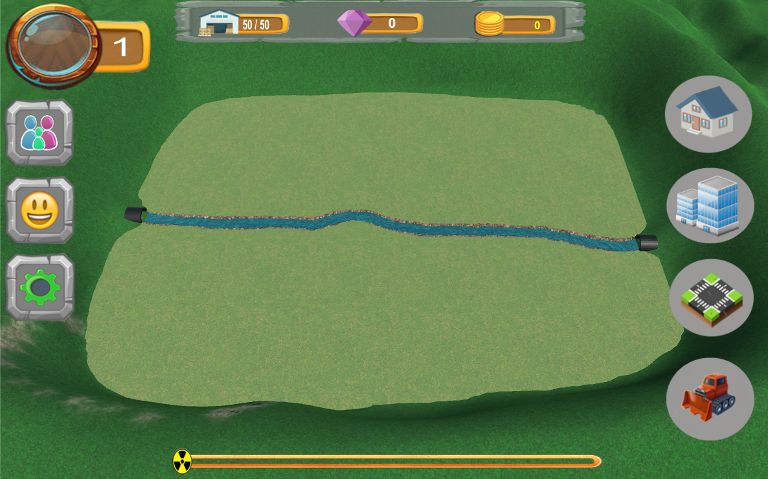

#### Some constructions:

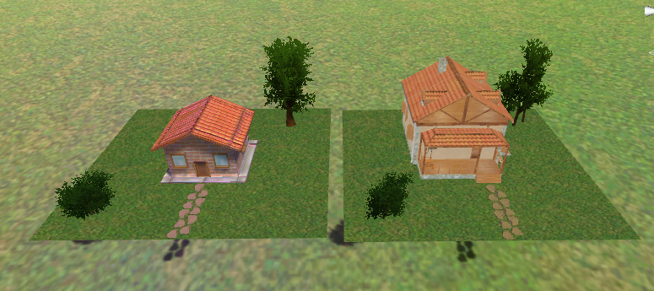Houses.

Buildings

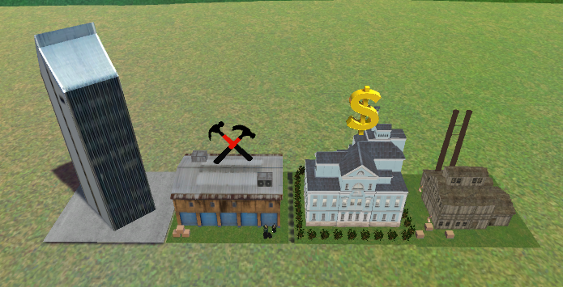

Streets

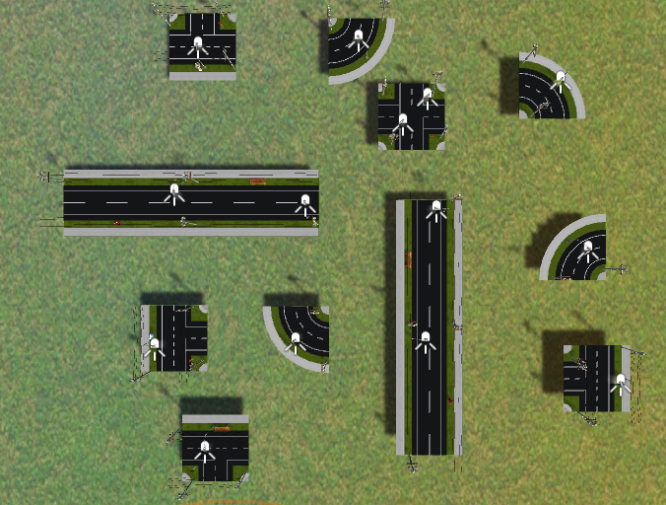

## SCOPE OF THE PROJECT.

After the project is finished, the game should allow the user to build houses, buildings and streets and receive feedback regarding money, experience, number of inhabitants and pollution.

# SECTION 2 - HISTORY, ENVIRONMENT AND CHARACTERS:

The characters of the game are the mayor, Bob the builder, and the different elements available to build.

THE MAYOR: It is the role played by the player.  
BOB THE BUILDER: He is in charge of directing the constructions in your city.

## HISTORY AND NARRATIVE

Medellín is a new city in Colombia, and you are the elected mayor of this new city. You will be in charge of its growth and prosperity, but be careful with contamination.

## NARRATIVE DESIGN

The game is composed of a desert terrain, where you can see some rocks and trees and a river that divides the terrain into 2, the player can build on the flat ground, and is forbidden to do so in the mountains, you can also remove the trees, rocks and objects already built, and use that space for a new construction.

# SECTION 3 - GAMEPLAY AND VIDEOGAME MECHANICS

The player has control of the game through the mouse.

Imagen tutorial y mouse:

## OBJECTIVES

The game contains 5 different objectives that must be achieved by the player, but in addition to this the player must avoid that the indicator of pollution is completely filled and the prosperity of his city falls.

## MECHANICAL

The mechanics of the game is to select the object you want to build and position it with the mouse in the desired place, you must take into account that in order to build you must have the gold and the necessary materials. All this through the mouse.

## PHYSICAL

The player has the mouse cursor and clicks to select and drag the desired construction to the desired place, you can also delete the objects by selecting the Delete button and then the construction or the object you want to delete. also the player can zoom in or out the camera thanks to the mouse scroll.

## MOVEMENTS

The player can zoom in or drag the camera for a better view of the map or where you want to build.

## OBJECTS

The game features 3D models of the terrain, as well as the different elements to build, trees, rocks and a river.

Also has 2D models for both materials, as Bob the builder who will be responsible for the construction of your city and give a short tutorial at the start of the game.

# SECTION 4 - LEVELS

**(poner imágenes o fotos aquí)**

## ENVIRONMENT

The environment of the game is composed of desert terrain similar to the land where the city of Medellin was built in real life.In this land you can see trees, rocks and a river.

# SECTION 5 – INTERFACES

GRAPHICAL USER INTERFACES

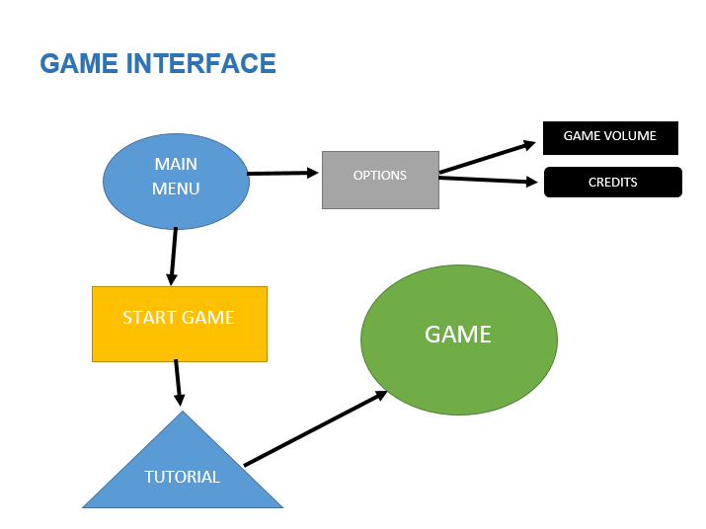

## INPUT DEVICES

The input device is the mouse, thanks to which the player can interact with the different elements within the game..

MUSIC

MENU MUSIC: https://freesound.org/people/PatrickLieberkind/sounds/396024/

GAME MUSIC: <https://freesound.org/people/Freed/sounds/93287/>

# SECTION 6 - TECHNICAL ASPECTS

Medellín CITY is designed for the Windows platform.

HARDWARE AND DEVELOPMENT SOFTWARE

|  |  |
| --- | --- |
| Componente | Modelo |
| Procesador | Intel Core i7-2600 @3.40GHz |
| RAM | 8GB DDR3 |
| Motherboard | Dell 0Y2MRG |
| Monitor | Dell LCD 22’ |
| Periféricos | Mouse. |
| Disco duro | 1.36TB |
| Tarjeta gráfica | AMD Radeon HD 6450 1GB |
| Sistema Operativo (OS/SO) | Windows 7 Professional SP1 |
| Motor gráfico | Unity 5.6 |

# SECTION 7 - BUSINESS

## MONETIZATION

The game is free and will only be for educational use

## PLATFORM

The platform where a publication will be made will be by BlackBoard informing about our project and can be tested by the educator in charge.